**Trigonometric Derivatives: Household Voltage and Current**

Power systems that generate, transmit, and distribute electrical power are designed to operate in the sinusoidal steady state condition. The operating frequency of household voltage and current in the United States is 60 Hz. Both 50 and 60 Hz systems are found outside the United States. The amplitude of household voltage is 120 Volts in the United States. Let *v(t)* represent a sinusoidal voltage source that is the standard in the United States.

 (Volts)

Passive electric circuits involve the interconnection of voltage sources with three types of components:

1. Resistors
2. Inductors
3. Capacitors

The analysis of AC electric circuits involves determining the relationships among various voltages and currents that are present in a circuit that is powered by sinusoidal voltage sources. In order to accomplish the analysis of AC electric circuits, it is essential to know the relationship between voltage and current for each of the 3 passive components identified above. These relationships are provided below.

1. Resistor 
2. Inductor 
3. Capacitor 

In the case of the resistor, the voltage and current maintain the same general form.

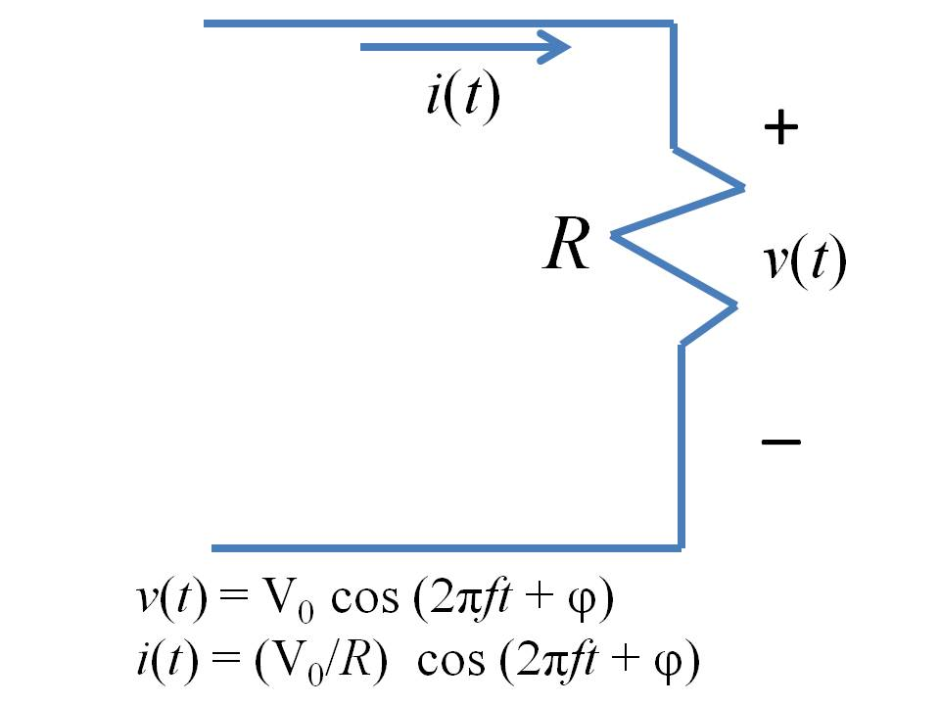

In the case of the inductor, the waveforms for the voltage and current remain sinusoidal. The two waveforms differ in phase.

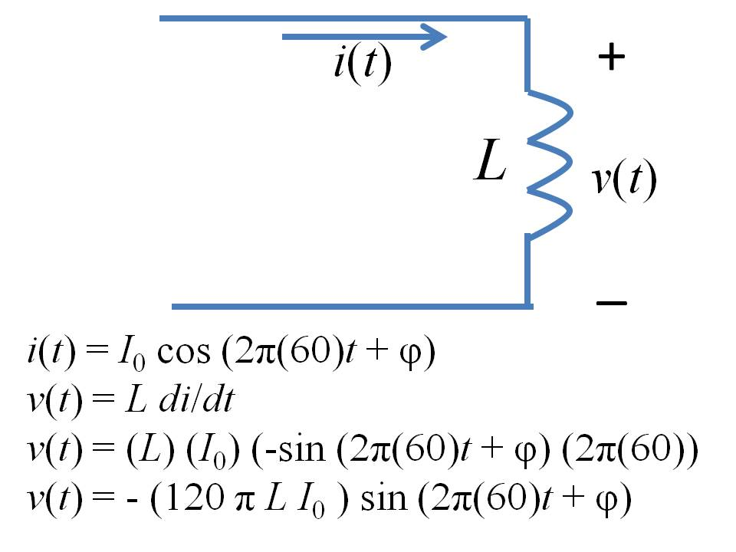

In the case of the capacitor, the waveforms for the voltage and current remain sinusoidal. The two waveforms differ in phase.

